Geometry: Unit 3, Lesson 8
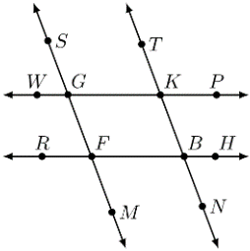
- Lines $WP$, $RH$, $SM$, and $TN$ are shown. $\overset{⃡}{WP}∥\overset{⃡}{RH}$ and $\overset{⃡}{SM}∥\overset{⃡}{TN}$. What is an angle that is congruent to both $∠RFG$ and $∠BKP$?

$$∠FBK$$

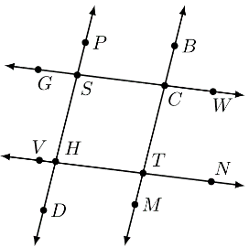
- Lines $GW$, $VN$, $DP$, and $MB$ are shown. $\overset{⃡}{DP}∥\overset{⃡}{MB}$ with traversals $\overset{⃡}{GW}$ and $\overset{⃡}{VN}$. What type of angles are $∠MTN$ and $∠VHD$?

Consecutive exterior angles

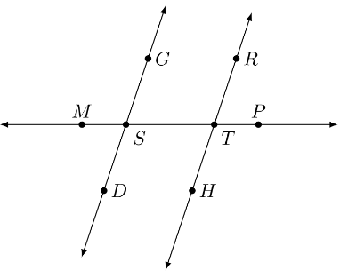
- Lines $DG$, $HR$, and $MP$ are shown. If $∠PTR$ and $∠MSG$ are supplementary, why are lines $DG$ and $HR$ parallel?

If consecutive exterior angles are supplementary, then the two lines that are intersected by a transversal are parallel

